php -v

For creating localhost :

php –S localhost:4000

* **PHP :-**
* server side scripting language
* generate Dynamic web pages
* interpreted language, scripts are parsed at runtime

xampp

variable ,concatination

values in array are called elements

Associative array

A session is a way to store information (in form of variables) to be used across multiple pages.

Session variable store information about a user session

14/04

Vhost:-Virtual host

Dev.training.com =c/xampp/htdocs/project

Abc.com/student/marks

* Host –abc.com
* Controller -student
* Function-marks

How to create vhost in apache??

What are hooks,autoloader in codeignitor??

OOPS CONCEPT-PHP

Offlinehelp :- user_guide

Singleton Approach in PHP

The purpose of **Singleton** design pattern is to always have a single instance of a some class. **Singletons** are usually used for things you don't necessarily need multiple instances of such as database or logging or similar. You always work with same instance of a **singleton** object.

Pre tag

Create login page of our project?

Data tables – jquery

CDN

A content delivery network (CDN) refers to a geographically distributed group of servers which work together to provide fast delivery of Internet content.

LOGIN CREDITIONAL:-

* dev.honohr.com
* SMS0286

Error_reporting(E_ALL)-for development

[https://codeigniter.com/userguide3/tutorial/create_news_items.html](https://meet.google.com/linkredirect?authuser=0&dest=https%3A%2F%2Fcodeigniter.com%2Fuserguide3%2Ftutorial%2Fcreate_news_items.html)

**table;**

student :

student id,class,name,class

marks

join,

INDEX ,RELATIONSHIP

**20/04**

Second highest marks

1. SELECT MAX(m_marks) FROM `marks` WHERE m_marks not IN (SELECT max(m_marks) from marks);
2. SELECT m_marks FROM marks ORDER by m_marks desc limit 1,1

Not given the exam

1. SELECT t1.stu_name FROM student t1 inner join marks t2 on t1.stu_id=t2.stu_id where t2.m_marks is NULL;

HTML 5 AND CSS 3

21/04

AJAX

Client side-> Ajax ->Server side

$.ajax({

    url: "test.html",

    data: $("#form_id").serialise(),

    method: post,

    cache: false,

    success: function(html){

      $("#results").append(html);

    }

  });

Jquery Validations

Basic understanding of Jquery

22/04

W3school:-

* Tables
* Lists
* [https://www.w3schools.com/html/html_blocks.asp](https://meet.google.com/linkredirect?authuser=0&dest=https%3A%2F%2Fwww.w3schools.com%2Fhtml%2Fhtml_blocks.asp)
* [https://www.w3schools.com/css/css_border.asp](https://meet.google.com/linkredirect?authuser=0&dest=https%3A%2F%2Fwww.w3schools.com%2Fcss%2Fcss_border.asp)
* [https://www.w3schools.com/css/css_margin.asp](https://meet.google.com/linkredirect?authuser=0&dest=https%3A%2F%2Fwww.w3schools.com%2Fcss%2Fcss_margin.asp)
* [https://www.w3schools.com/css/css_padding.asp](https://meet.google.com/linkredirect?authuser=0&dest=https%3A%2F%2Fwww.w3schools.com%2Fcss%2Fcss_padding.asp)
* [https://www.w3schools.com/css/css_boxmodel.asp](https://meet.google.com/linkredirect?authuser=0&dest=https%3A%2F%2Fwww.w3schools.com%2Fcss%2Fcss_boxmodel.asp)
* [https://www.w3schools.com/css/css_display_visibility.asp](https://meet.google.com/linkredirect?authuser=0&dest=https%3A%2F%2Fwww.w3schools.com%2Fcss%2Fcss_display_visibility.asp)
* [https://fontawesome.com/v3.2.1/icons/](https://meet.google.com/linkredirect?authuser=0&dest=https%3A%2F%2Ffontawesome.com%2Fv3.2.1%2Ficons%2F)
* [https://www.w3schools.com/icons/fontawesome_icons_text.asp](https://meet.google.com/linkredirect?authuser=0&dest=https%3A%2F%2Fwww.w3schools.com%2Ficons%2Ffontawesome_icons_text.asp)
* [https://www.w3schools.com/css/css_max-width.asp](https://meet.google.com/linkredirect?authuser=0&dest=https%3A%2F%2Fwww.w3schools.com%2Fcss%2Fcss_max-width.asp)
* [https://www.w3schools.com/css/css_positioning.asp](https://meet.google.com/linkredirect?authuser=0&dest=https%3A%2F%2Fwww.w3schools.com%2Fcss%2Fcss_positioning.asp)
* [https://www.w3schools.com/css/css_float.asp](https://meet.google.com/linkredirect?authuser=0&dest=https%3A%2F%2Fwww.w3schools.com%2Fcss%2Fcss_float.asp)
* { display: block; margin: 0 auto;}

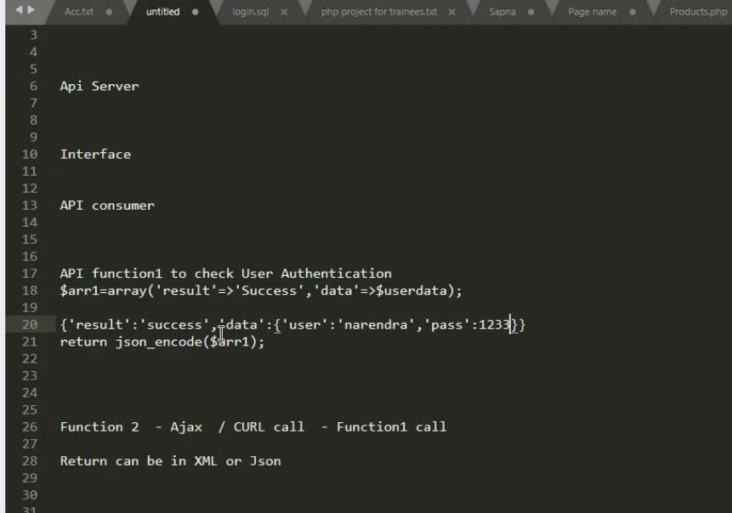

<https://ultimatefosters.com/hosting/setup-a-virtual-host-in-windows-with-xampp-server/>

Project Modification:

       I.          Header with logo in all pages

     II.          Logout –top right corner

    III.          Footer –copyright text in all pages

    IV.          Header-Menu(beside logo):- View all employees

     V.          Welcome username- top right corner

    VI.          View page- add new button in top right corner

  VII.          Breadcrumb – under page title mention home/link/view all employees

VIII.          Forget password caption-submit

    IX.

How to create a company?

How to give access to the role?

How to create a new menu?

How to create a custom role(recruiter +manager)?

How many modules are there??

Different types of rules?

WAP to design pyramid of stars

WAP $a=”1,2,3,4,5,6,7,8,9,10” to sum all these values.

Hint :- explode(),implode(),strstr,stristr,strpos,trim,array_sum,array_rev,strip_tags

Global variables $_SERVERS,$_POST,$_GET,$_REQUEST,$_FILES

<form enctype=”multipart/form-data” method=”post” action=””><input type=”file” name=”file1” >

<input type=”submit” name=”submit” value=”submit” >

</form>

PHP functions :

1.      Copy(source_path,destination_path,true/false)

2. Move_upload_files(source_path,destination_path,true/false)

ini_set(name of arg,value)

sanity check of forms

SQL injection

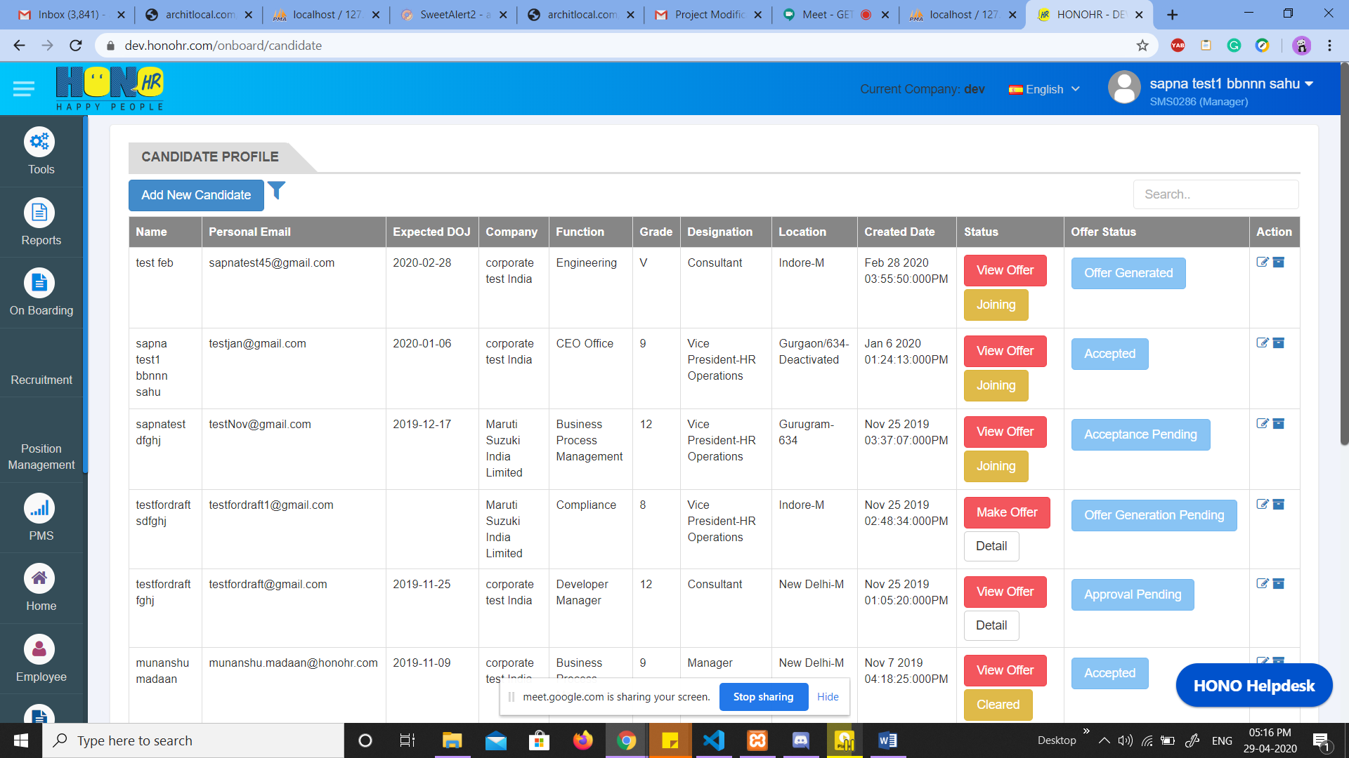

30/04

ADD 20 records

List down 20 records through query

Add search

Add pagination with 5 records each page